**Recommender Systems are of 2 types:**

* Content Based RS
* Collaborative Filtering RS

**Collaborative Filtering:**

It works based on collaboration using matrix A we seen in early lecture.

Let’s say matrix is given as below where:

U1 has watched m1, m2, m3

U2 has watched m1, m3, m4

U3 has watched m1

Now we need to recommend a movie to U3, so what we do is search all the users who has watched m1 movie, so u1 and u2 are there,

now we’ll find the common movies watched among U1 and U2, which is m3, so we recommend m3 to U3.

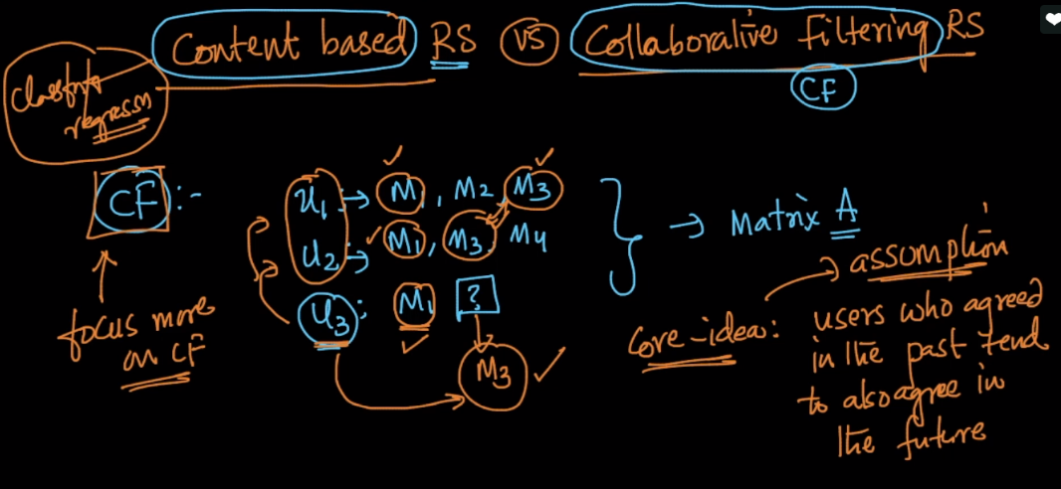

**Content Based RS:**

Here we not only use A matrix but also use features of movie and user and then use value in A matrix as output. So this become the classification and regression problem.

So we find the feature for user movie as is_Action, is_Drama, decades_of_movie(90’s), actor, director

Features for user as likes_action_movies, likes_romantic, gender, location, age_group.

Now combine these features along with output from Aij, now we’ll train model using them and can get recommendation for user with new items.

